LIFE GROUPS
CLCC Ministries & Online Communities

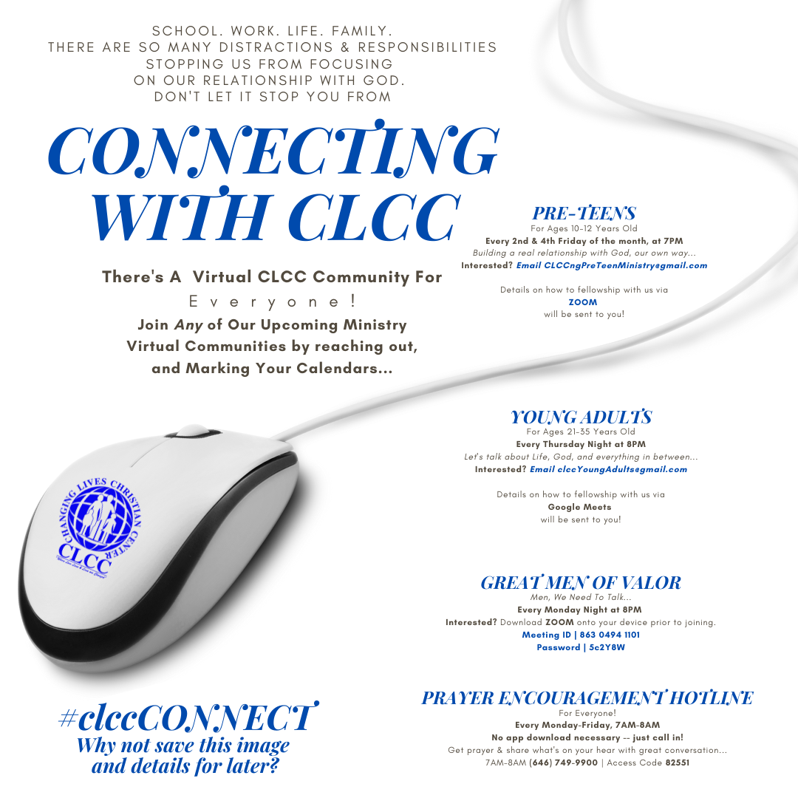

Feel Free To Communicate Any Further Inquiries and/or Concerns
- 272-8277 / info@clccMinistries.com

